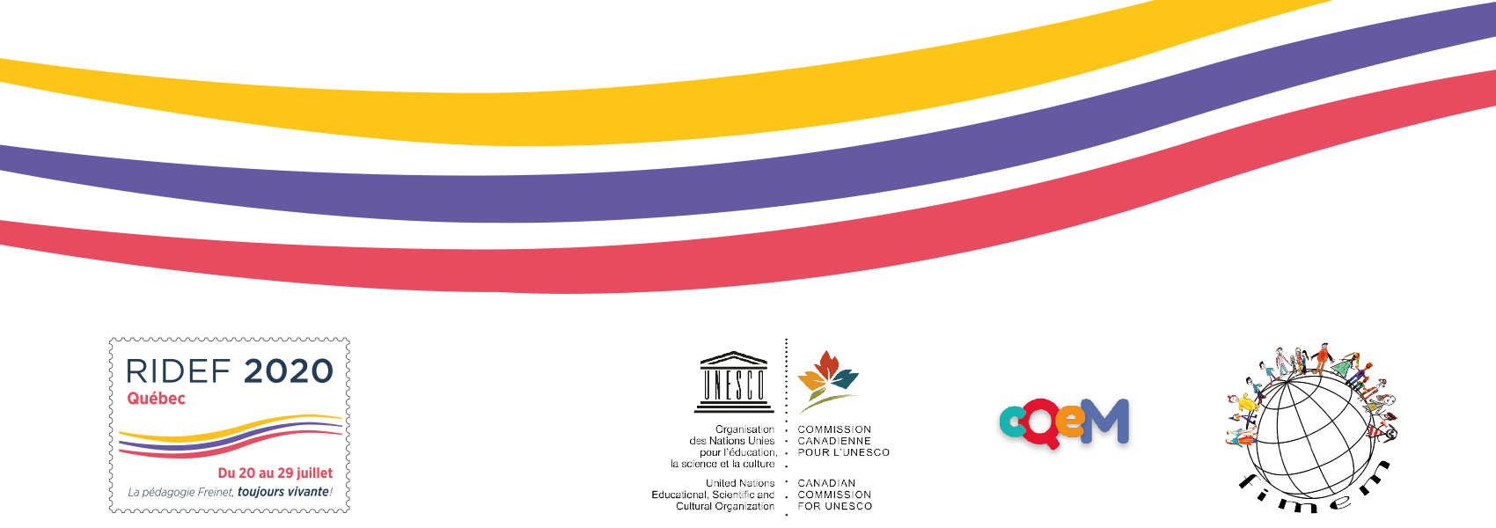

News from Quebec (Canada)
1. The ridef.one website goes to our Facebook page
Since the Ridef QC-2020 site has had little or no consultation since the cancellation of the Ridef on April 5, the new information will now be sent, depending on the target audience, through our Facebook page and through emails sent directly to the Movements.
The Ridef.one site will remain open and accessible at all times...you will find everything we had prepared for you.
2. Finances
Thanks to the generosity of many donors, both local and international, we have managed to recover all the sums needed to pay the expenses incurred for the preparation of the Ridef.
The financial health of the RIDEF-QC-2020 has survived the Covid and the reimbursements of the registrations refunds have started.
We take this opportunity to express our gratitude to all these donors.
3. Great celebration
When public health permits, the OC will invite all its volunteer "Freinétiques" to a festive moment of reunion and recognition for the huge amount of work accomplished.
We all need it! We'll be thinking of you!
4. Global report
In the autumn of 2020, the OC will finalise its last mandate: the drafting of the global report on the preparation of the Ridef 2020.
Have a great summer!
The organizing committee (OC) of the Ridef 2020.

