AGV3 - Sunday 30 August 2020, 18 HOURS (deepl translation)

After discussions it was decided that the secretariat would be held by Agnès J. and Rémi B. from 6 p.m. onwards.
Lullu Müller led the assembly. Lanfranco Genito is in charge of voting.

Lanfranco :
Problem with the Burkinabe delegation. The official proxy is Karim who is not present but another person, Wango, is present. Karim did not reply to the message sent by Lanfranco to get his agreement to delegate the mandate.
Everything was done according to the norms: for Greece, Sofia replaces the official delegate but this was agreed beforehand, which is not the case for Burkina Faso.
Since then, this Wango person has been present but does not speak.
Mariel clarified that both (Karim and Wango) participated in the preparation of the GA as members from Burkina.
Lanfranco: This is not true, Wango is just a participant.
Mariel: One can ask Wango
Sylviane: I wrote to him, he didn't answer, he doesn't speak.
Lan: In the previous chat, Wango wrote that Karim has no connection.
The connection doesn't work anymore and Wango can't answer.
Gabi: Is Wango or not Wango?
Lanfranco: Yes, but he is not a delegate.
Gabi: Do we have a quorum and start the GA?
Lanfranco makes the call of the delegates :

Germany FKEV: Brigitta Kovermann, Hartmut Glanzel,
Austria FreinÖ: Wanda Grünwald,
Belgium EPB: Henry Landroit
Belgie Nederlandstalige FBV: Katrien Niels,
Benin ABEM: Innocent Bosso,
Brazil REPEF: Glaucia Ferreira,
Bulgaria MEMB: Antoaneta Kalenderova,
Burkina: MBEM: Karim Nikiéma (absent)
Cameroon AECEMO: Monique Maria,
Canada-Québec CQEM: Sylvie Cartier,
Chile CEFC: María Núñez
Côte d'Ivoire AIEM: Basile Coffi Ballo,
Spain MCEP : Alfredo López,
France ICEM: Gwenaelle Bérillon, Karine Jaffré, Léonoard De Léo, Nicolas Mathey,
Greece SKASIARHEIO: Sofia Lahlou,
AdF: Joël Potin,
Italy MCE: Giancarlo Cavinato, Anna d'Auria, Nuccia Maldera
Japan GGUJ: Miki Igari,
Morocco AMEM: Asma Id Babou,
Mexico MEPA: Teresita Garduño,
Mexico MMEM: Marco Mendosa,
Poland PSAPF: Justyna Gorce-Bałut - absent at this time; present, later
(Chat) From Justyna to everyone: 07:24 PM
I cant change my name at The moment but i am delegate from Poland. can i vote?
Senegal ASEM: Cheikh Makhfousse, Sadikh Diaw,
Sweden KAP: Mia Vävare,
Switzerland FGS-GSEM: Andi Honegger (did not vote),
Togo MOUVEN: Hamidou Traoré Salifou, Florence Patchidi,
Uruguay MEPFU: Gabriella Varaldi

"31 delegates/36, quorum reached; 90 present".

Lanfranco: We have a form (only for delegates) with the 5 names of the candidates (Antoinette, Glaucia, Marguerite, Cheihk, Mohamed), with boxes to tick. 7 possibilities: candidates and abstention and blank vote.
A room is ready for voting, only for delegates.
Glaucia has a request: do the candidates present themselves quickly?
Sadikh : It is important that the candidates present themselves to say their ambitions for FIMEM and its Board as in a RIDEF.
Mohamed: I would like to point out that the candidates were not presented according to the dates of application. This is important.
Lulu: The candidates will present themselves and then we will vote.

Marguerite from ICEM (France)
I am here because the international sector of the ICEM felt it was necessary to nominate a person and I was asked to apply. My work will be supported by an active ICEM group to further the objectives of the ICEM.
I am retired, I have time. I have taught children of all levels in the first grade up to 11 years old. I continue this work by teaching Freinet, through writing workshops, in a social and political commitment to migrant people (young people and adults).
I have worked at the ICEM at the departmental, regional and national level as I am ending my mandate on the ICEM Board (6 years).
I haven't travelled much - I did a RIDEF - but Freinet pedagogy is international in essence (it is written in the ICEM's charter of the modern school) and it is important in defending our values against neoliberalism which is also international.
My concern: the rights of the child and emancipatory education.

Glaucia from REPEF (Brazil)
This candidature recently appeared during a meeting with the EMNFA group that proposes to support me in my work.
Our federation has its culmination in the RIDEFs. They are for me a moment of training. The life of FIMEM is more explicit in the RIDEFs.
I have some concerns about all the efforts made there and the results obtained.
My first concern is the life of the FIMEM movements. We know very little about the specificities of each country, its organisation, its history, its economic and political problems that reality imposes. How does Freinet's pedagogy contribute to a political vision of education in each of the countries that make up FIMEM?
Another point is the RIDEF, the place where Freinet pedagogy is debated against the neo-liberal advance. What conception of work for educators in the face of capitalism and exploitation that aggravates inequalities? Such debates can only be organised during such a large meeting; privileged moments should be encouraged.
Last observation: recent work has been productive thanks to the internet tools, this should serve as an inspiration for the next GC. We can hold more meetings by zooming in and reduce the travel expenses of the Board.

Mohamed from AMEM (Morocco)
Teacher from 18 years old, in primary, middle and high school and in a teacher training centre. Very early on, I met the Freinet pedagogy and I was a member of the largest left-wing Moroccan trade union. My involvement in FP is linked to the difficult life children live in my country. Children's rights have become a sensitive issue since the 1990s. I have been working in this direction at the national level on the educational programmes.
I have participated in 5 RIDEFs, 1 of which was African. I have organised, with the comrades in Morocco, the third African meeting of Freinet educators (RAEF) after the one in Senegal. I speak 3 or 4 languages.
My candidacy is linked to the absence of an African candidacy to the FIMEM. I explained to AMEM that it was not possible to prepare a RIDEF and to sit on the Board. The comrades tried to find a solution: I am therefore running for the FIMEM Board, but I am withdrawing from the organising committee of RIDEF 2022.
The biggest project: working north-south, on the rights of children in Africa. It is a large-scale project, to build a future for these oppressed children, to be carried out hand in hand with all the FIMEM movements, respect for public schools, for a social state where democracy prevails.
Morocco's candidacy was the first to be declared. I ask that the mandates of the members of the former Board be extended so that there is a Board of 7 to 9 members.

Cheikh of ASEM (Senegal)
I am a teacher by training. I was assigned to Diawar where I met Papa Meissa Hanne. Together we created ASEM. I only knew Freinet's pedagogy, with the support and supervision of Jean Le Gal, Sylvain Hannebique, and the others, Joël Potin...
I am a practitioner and trainer on Freinet techniques in Senegal and in Africa. I will soon be retired and I will be able to share my experiences with the FIMEM, one of the reasons why ASEM presented my candidacy.
I am a member and founder of ASEM and CAMEM where I am treasurer general. I participated in the RIDEFs in 2006 (Senegal), 2010 (Nantes) and 2012 (Léon) where I have always facilitated workshops. I took part with my students in the centenary of Freinet's birth at UNESCO in Paris in 1996 and in the Talence congress in France in 2002.
I am co-manager of the 2006 RIDEF. There was Andi as treasurer of RIDEF - we praise his skills. I am also co-manager of all the African meetings (RAEF). I was a trainer in Cameroon. In Senegal and Africa I co-wrote a book with Papa Meissa Hanne. I plan to write more about my future experiences.
When I am on the board I will be supported by ASEM (with experienced people, former members of the FIMEM board, and especially Papa Maissa Hanne, president of ASEM).
I have not been longer than the others.

Lulu: We're going to vote. Antoinette would like to extend her term of office by two years. The Board must have at least 5 members. You can vote for more than one person.
Is Antoinette standing for election? She is already known to everyone.

Lanfranco: We have 33 delegates who can vote.
Gabi asked to rename his name with the word delegate (DEL) to facilitate entry into the voting chamber.
Mariel asks: is it necessary to vote since there are 5 candidates and 5 places at least?
Andi: We always vote, and then there are 5 candidates + Lanfranco.
Lanfranco: We have to vote, in case someone has zero votes.
Toyaotzin: Innocent Boso has not joined the platform. [In fact, he is using Edouard's access].

Results of the vote:
Antoinette Mengue Abesso: 52% 17/33
Sheikh Makhfousse: 79% 26/33
Glaucia Ferreira: 85 % 28/33
Marguerite Gomez: 76% 25/33
Mohamed Id Babou: 76% 25/33
no abstention,
white 3 % 1/33
All 5 candidates are elected. The Board of Directors will be composed of 6 members (the 5 elected + Lanfranco Genito which continues its mandate).
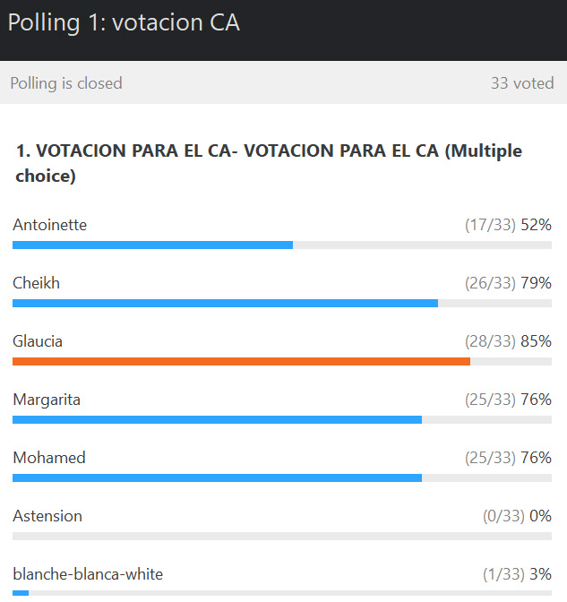

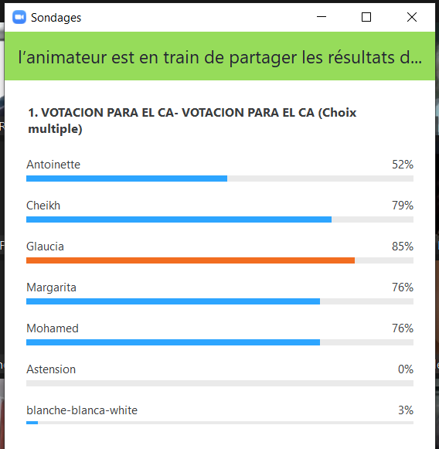

How much time do we have? We can stay longer, but he'll know when to stop.
Budget or affiliations and RIDEF then how do we extend by email?
Mia proposes to make the budget and then postpone the other points.

Budget, so that the new Board can work
Sylviane: There are two requests for changes: Benaiges grant + 500 euros and another proposal from Gita.
Where do we take the 500 euros?
Tere: from the Board of Directors' trips.
Sylviane proposes to vote on this proposal.
Do we accept the budget with +500 euros for the Benaiges grant and -500 euros for the travel of the Board of Directors?
Abs : 6
against : 0
for : 16

Gabi: there are several themes that we won't be able to address. I propose to continue for 30 minutes and then to list what we will have to tackle soon.

Hortensia: asked Mohamed about the current situation of the Moroccan movement and how to envisage RIDEF 2022.
Sylviane: Create a structure so that the future Board of Directors can deal with all the pending themes rather than each one saying what it is interested in as a priority.
Tere: It is important to talk about RIDEF and the new affiliations that require all of us to be present and all the other themes afterwards.
Mariel: start by letting Congo and Ghana speak, as they have been waiting for several years for their affiliations.

Affiliations
Mia: too little time to talk, need to find a better time because tomorrow morning she has to get up early.
Andi: doing it in Morocco in 2022 rather than now in 10 minutes!
Mia: Ghana has worked hard to become an affiliate. If we can do it quickly.
Gabi: vote today because they have been waiting for a long time. And if it's too difficult to discuss it virtually, we should have said so earlier otherwise it's disrespectful.
John, from Ghana: would like us to discuss membership now, not in two years' time.
Mariel proposed a show of hands.

Presentation by Ghana: John Mensah is President of the Freinet Group. He has collaborated for the opening of several Freinet schools and has been in contact with people from Benin, India, Sweden and the Gambia.
He went to Sweden to visit Freinet schools for 2 weeks.

Presentation of Congo by Cameroon (sponsors) :
Marie-Catherine (from Cameroon): Private schools, but members of the Congolese movement work with public teachers.

Tere: in REMFA and the Spanish-Italian-Portuguese language group, we shared our thoughts about these affiliations, we contacted them. They answered all our questions, starting from the charter of the modern school, more public schools, public schools [????].
Protect secularism in school to work in a scientific way. We approve of their presence in the federation.
Iena : I agree with Tere : in our charter ; secularism, public and free schools. What kind of school do you work in? Are they really free for your students?
Answer: In Ghana they follow all the government programmes.
Antoinette (from the sponsor movement in Congo): All Africans closely follow what is being done in Congo. We work together and we can say that in the future we will ensure that the charter of the modern school, secular school, free school, is respected. We support this candidacy and we will follow up on the application of the charter of the modern school.

Vote for the affiliation of Ghana :
abs : 6
against : 2
for : 18 ? 17 ?
Ghana is a new member of FIMEM.

Vote for the affiliation of Congo :
abs : 4
against : 1
in favour : 19 or 20
Congo is a new member of FIMEM.

RIDEF 2022
Tere: I propose that the RIDEF commission work with the Moroccan movement to ensure that this RIDEF is held.
Karine joins the RIDEF commission.
Mariel: We should work with the site commission (there are 3 of them).

Giancarlo: In the Spanish-Portuguese-Italian language group, we propose that a future RIDEF - it would be good if it were held in Morocco - should have democratic participation as its theme. This would be important for our federation, for education. The last themes were not appropriate to our present life.

Mohamed: The Organising Committee of RIDEF 2022 is working while waiting for the possibility of a face-to-face meeting of its members (exchanges on WhatsApp created on 05/05/2020). Contacts by email and telephone have made it possible to continue working individually on very specific subjects. This obligation made it possible to define certain responsibilities within the large group (2 groups, one in Agadir, the site where the RIDEF will be organised, and the other in Tiznit at the association's headquarters).
A Planning has been drawn up (see on the FIMEM website). A direct contact, in October 2019, took place with the president of the university which ensures the support of the Ministry.
Dates: from 20 to 30 July.
Mariel: Do you plan to continue the site used by the Quebec movement?
Site: We have an AMEM site, but it needs to be upgraded. We haven't decided yet, the FIMEM site is too complicated.
We want to make a RIDEF with a profit.
A committee of 6 people will be set up with the president of CAMEM.
We want to get in touch with the Quebec organising group to benefit from their experience of the site; we would like a member from Canada to come to Morocco.

Marco asked that the members of the old and new Boards agree on a date when a new GA (to be completed) will be convened.

Rémi B. reported that his participation in Commission #1 was a decision making process for the GA. He therefore withdrew and a new coordinator will have to be found.

Cheikh: We thank the GA for the confidence in electing us. I intervene to confirm CAMEM's support for AMEM. How can we support AMEM?
Create a community of 9 members: 3 Moroccans, the president of CAMEM, the treasurer general, 2 presidents of the RAEF OC from 2006 and 2016; plus 2 members who will be co-opted.

Gabi: This situation was complex, the ODJ too large. Technical problems always occur ... our apologies. It would be necessary to meet again.

